作业1(2022年7月4日)

19200300004 黄铭瑞

**作业内容:**



**答:**

1. Gx的纵向纹理明显,Gy的横向纹理明显.

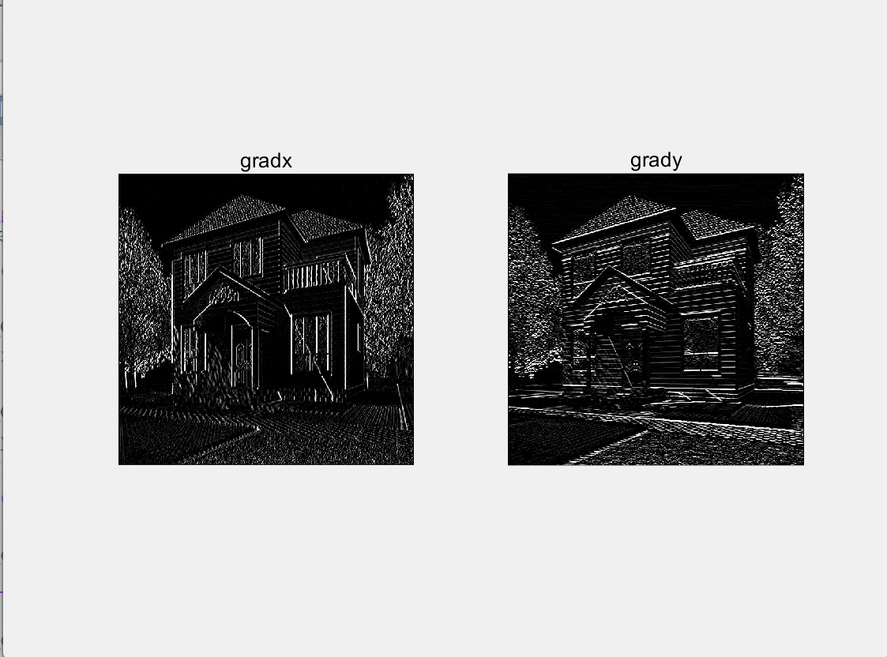

(Gx和Gy输出)

2. 绝对值法的得到的纹理要比平方和开方的到的纹理要重一些.

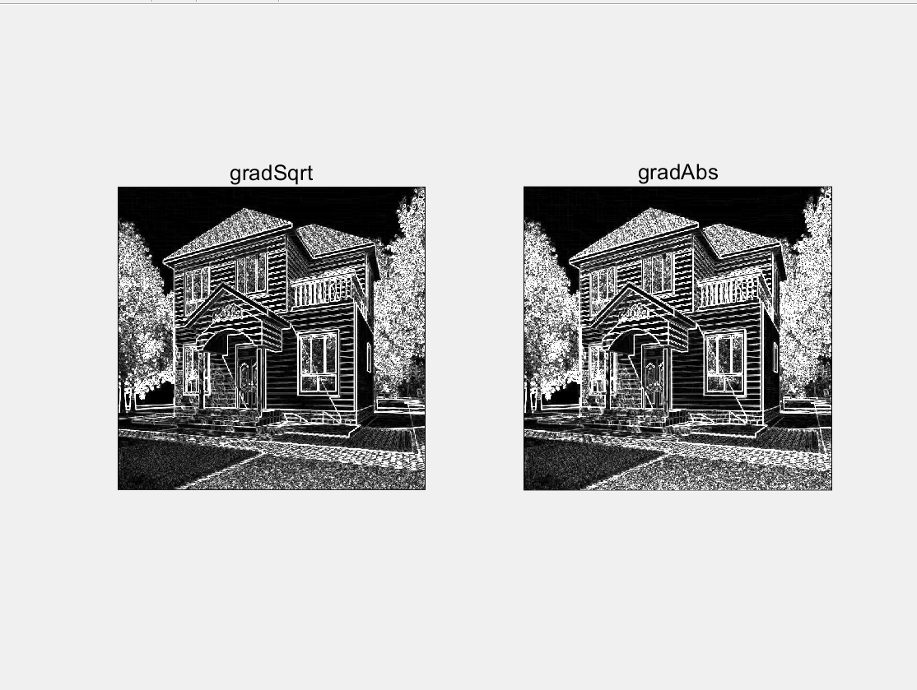

(平方和开方法和绝对值法)

3.可以看到,输出图像边缘的像素值为0,为无效值.

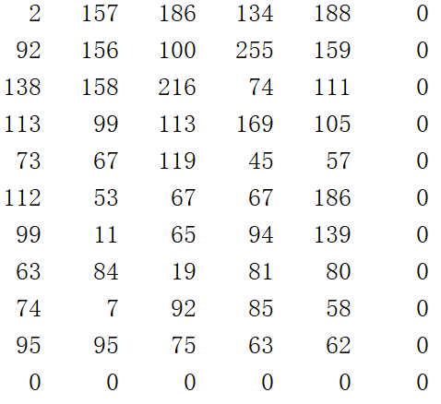

(部分边缘像素值)

需要对原图进行padding. 使用padarray函数对原图四周进行单行单列的镜像padding,重复边缘检测操作,最后删除四周空白无效的行和列,恢复原图大小.得到边缘像素有效的输出.

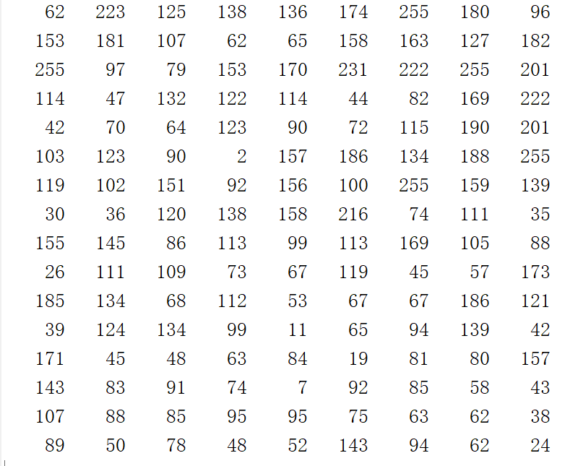

(边缘像素有效)

**附录**

day1_sobel.m

img = imread('house.png'); % 读取图像转为灰度

img = rgb2gray(img);

[high,width] = size(img); % 获得图像的高度和宽度

pix = double(img);

img_Gx = uint8(zeros(high, width));

img_Gy = uint8(zeros(high, width));

img_out1 = uint8(zeros(high, width));

img_out2 = uint8(zeros(high, width));

for i = 2:high - 1 %sobel边缘检测

for j = 2:width - 1

Gx = (-pix(i-1, j-1) - 2*pix(i, j-1) - pix(i+1, j-1) + pix(i-1, j+1) + 2*pix(i, j+1) + pix(i+1, j));

Gy = (-pix(i-1, j-1) - 2*pix(i-1, j) - pix(i-1, j+1) + pix(i+1, j-1) + 2*pix(i+1, j) + pix(i+1, j+1));

G_sqrt = sqrt(Gx^2+Gy^2);

G_abs = abs(Gx) + abs(Gy);

img_Gx(i, j) = Gx;

img_Gy(i, j) = Gy;

img_out1(i,j) = G_sqrt;

img_out2(i,j) = G_abs;

end

end

% 显示灰度图

figure('Name', 'img_gray');

imshow(img);

title('imgGray');

% 显示x梯度和y梯度边缘检测图

figure('name', 'gradx & grady');

subplot(121);

imshow(img_Gx);

title('gradx');

subplot(122);

imshow(img_Gy);

title('grady');

% 显示开平方和绝对值的边沿检测图

figure('name', 'sqrt & abs');

subplot(121);

imshow(img_out1);

title('gradSqrt');

subplot(122);

imshow(img_out2);

title('gradAbs');

% 对原图边界进行扩充

img_padding = padarray(img,[1,1],"symmetric","both");

[h, w] = size(img_padding);

pix2 = double(img_padding);

img_Gx2 = uint8(zeros(h, w));

img_Gy2 = uint8(zeros(h, w));

img_out12 = uint8(zeros(h, w));

img_out22 = uint8(zeros(h, w));

for i = 2:h-1 %sobel边缘检测

for j = 2:w-1

Gx2 = (-pix2(i-1, j-1) - 2*pix2(i, j-1) - pix2(i+1, j-1) + pix2(i-1, j+1) + 2*pix2(i, j+1) + pix2(i+1, j));

Gy2 = (-pix2(i-1, j-1) - 2*pix2(i-1, j) - pix2(i-1, j+1) + pix2(i+1, j-1) + 2*pix2(i+1, j) + pix2(i+1, j+1));

G_sqrt = sqrt(Gx2^2+Gy2^2);

G_abs = abs(Gx2) + abs(Gy2);

img_out12(i,j) = G_sqrt;

img_out22(i,j) = G_abs;

end

end

% 恢复原图大小

img_out12(all(img_out12==0,2),:) = [];

img_out12(:,all(img_out12==0,1)) = [];

img_out22(all(img_out12==0,2),:) = [];

img_out22(:,all(img_out12==0,1)) = [];

% 显示padding后的边缘检测图像

figure('name', 'padding: sqrt & abs');

subplot(121);

imshow(img_out12);

title('gradSqrt');

subplot(122);

imshow(img_out22);

title('gradAbs');

img_out12